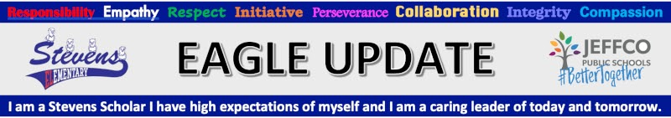
Office 303-982-2198 Attendance Line 303-982-2180

Calendar
Fri 8/27 | Flex Testing for K-5, by appointment, teachers will be contacting you
Mon 9/6 | No School - Labor Day
Tues 9/7 | After school Clubs start - sign up sheets will go home Monday 8/23
Thu 9/9 | 6pm PTO Meeting on Zoom
Wed 9/22 | Picture Day
 | Printable Stevens Family Calendar

Hi Sevens Families, It was an awesome week! We were all so thrilled to have our building full of smiling, brave, silly, knowledgeable, awesome kids! And so nice to see all the staff that worked remote last year too. We are looking forward to an awesome year!

NEW! MASKING - All students and visitors 2 years old and up MUST have a mask on to enter the school. Please have one with you when you arrive. See entire statement from Jeffco Public Schools here.
NEW! Parking and Dropoff - Please be aware that parking and drop off procedures help us keep kids and other safe and help us have good relationships with our community neighbors.
- Park only in designated school parking spaces
- Do not park and get out of your car in the bus lane
- Do not park and get out of your car in the drop off lane, Hug and Go!
- Do not ever park in the Grange or Wheat Ridge Cyclery parking spaces or any other businesses near the school. They need these spots open for their customers and employees.

NEW! Attendance Reminders:
- Students are considered tardy if they arrive after 8:20 am. At 8:30am the cafeteria doors will be locked and students must enter through the front doors and sign in at the office. (students arriving late due to school bus being late will be excused)
- If your student is not coming to school please call the attendance line by 8am 303-982-2180.
- If anyone in the household is getting a Covid test, students who live in the same household should be kept home till test results are back.

School Fees can be paid online through Jeffco Connect - look for the link when you are updating your account.

Fill out your Free and Reduced Meal Application www.SchoolCafe.com. This link is also in Jeffco Connect. Why should you apply? See important information below.
We Have a New Family Engagement Liaison: We are excited to introduce you to Anita De Leon. Anita is anxious to meet all of our amazing students and their families. Feel free to contact her if you need ANYTHING! She is awesome and ready to go! anita.deleonbannister@jeffco.k12.co.us
Red Rocks Child Care - Please click HERE for more information regarding before and after school care. Registration opens Aug 2.
Friends of Stevens PTO: friendsofstevens.org
Friends of Stevens is a group of community members, families, staff and students who are dedicated to furthering the work and mission of Stevens Elementary School. We connect individuals and groups with opportunities to provide students at Stevens Elementary School with materials and tools to learn in a hands-on ways and to support and lift up our teachers and staff.
Please contact our PTO President, Jen Cross if you’d like more info. or if you have any questions regarding Friends of Stevens PTO, jenbowencross@gmail.com.
Meeting schedule:
Sept 9th - 6pm
Nov 11th - 6pm
Jan 13th - 6pm
Mar 10 - 6pm
May 12 - 6pm

Balón USA is a free after-school soccer program for girls and boys in 3rd-5th grades. Flyer

